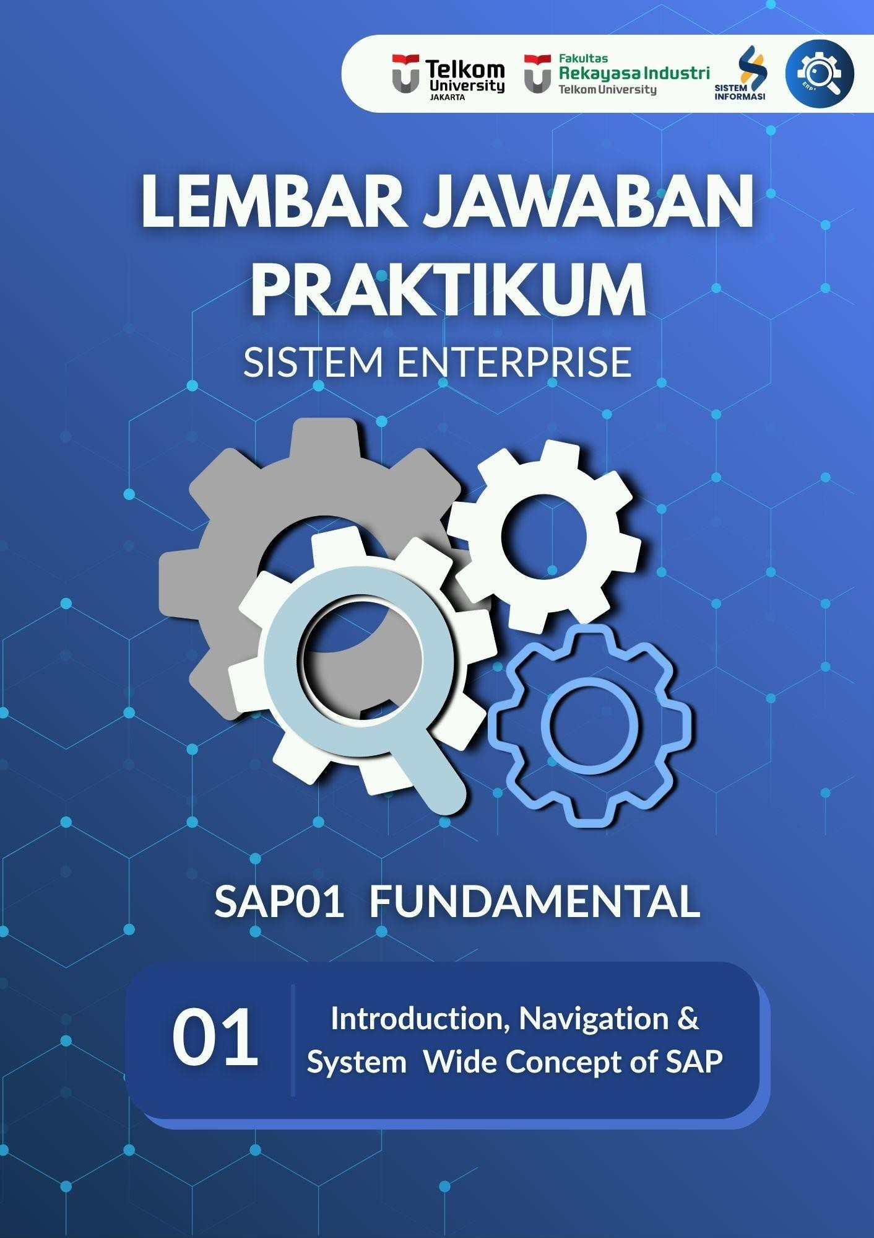

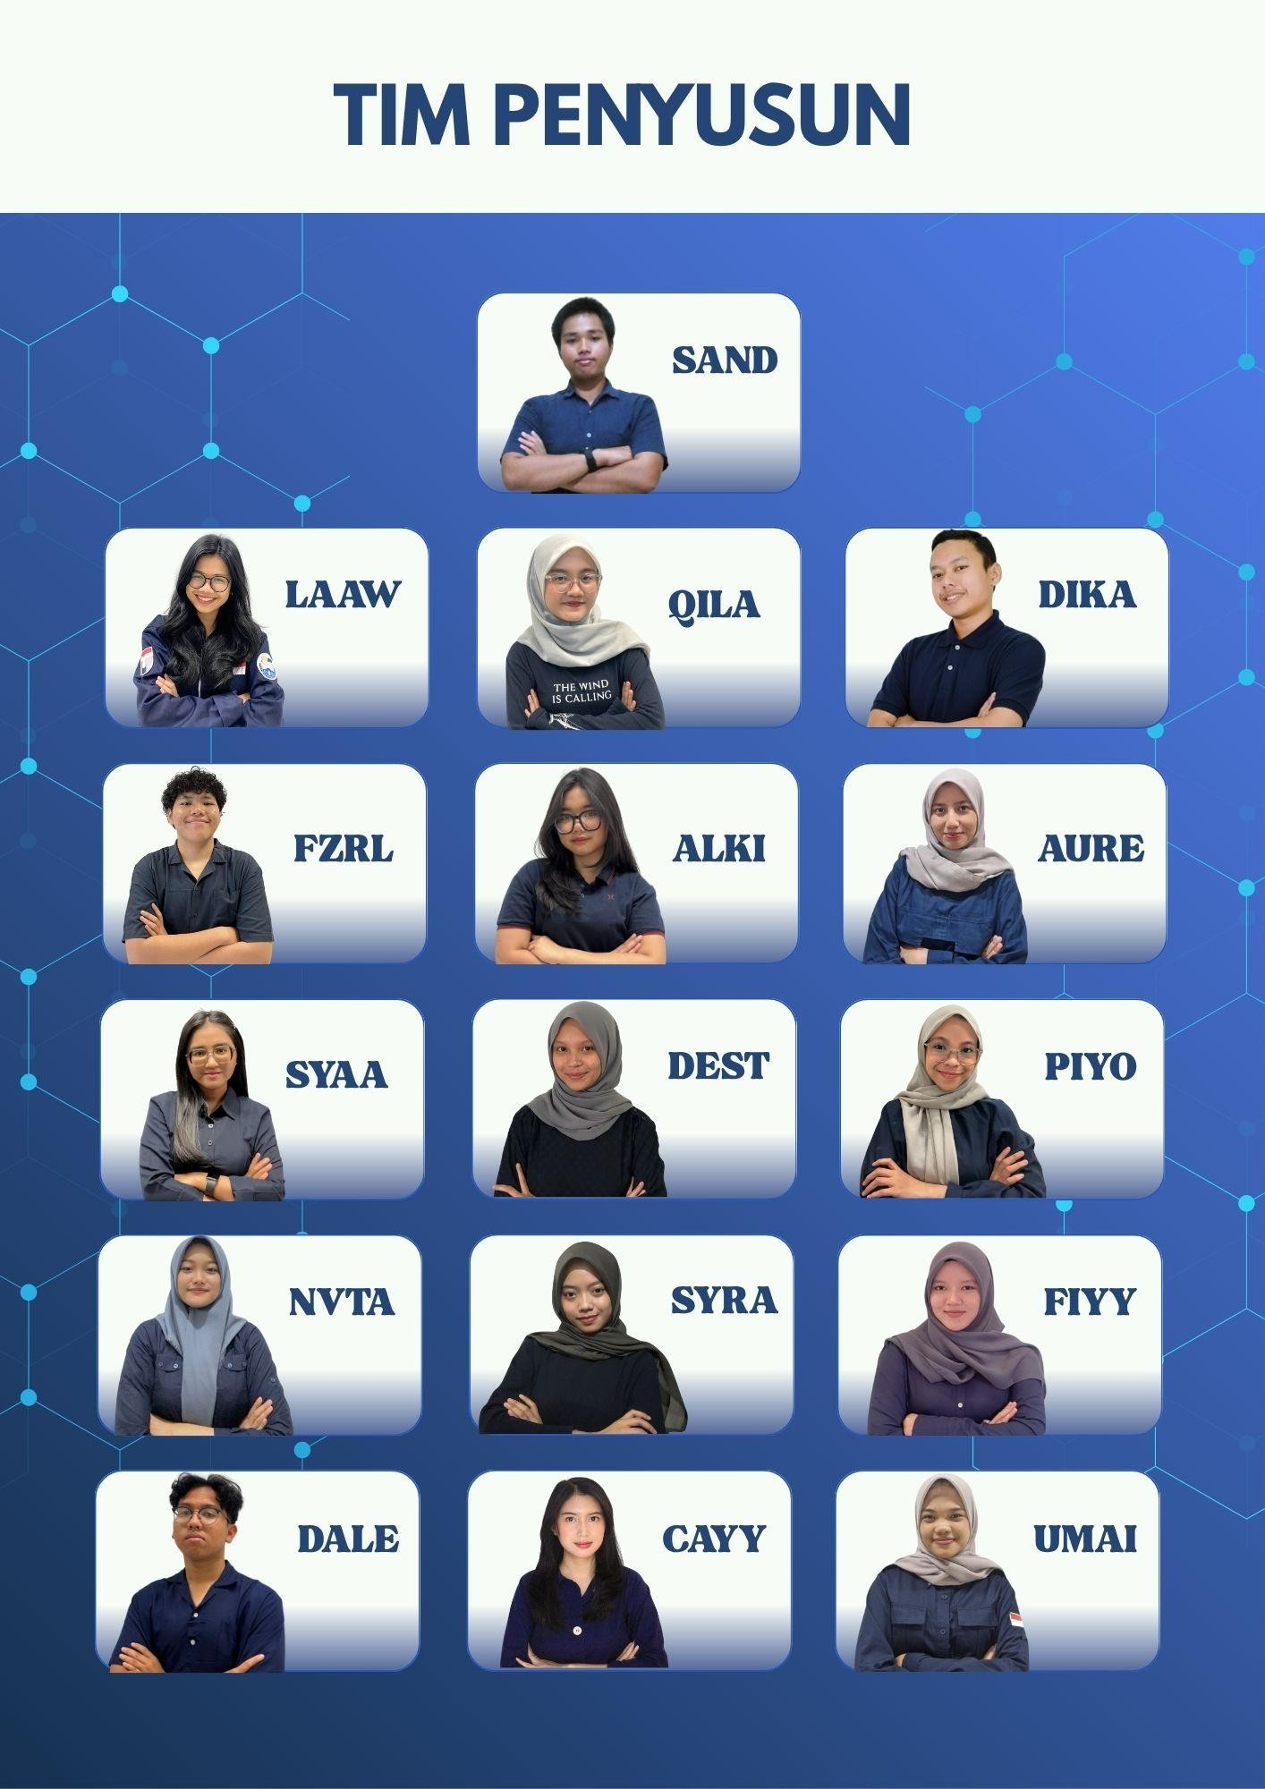

# A screenshot of a phone AI-generated content may be incorrect.RULES FOR TAKEHOME



Kerjakan tugas Takehome secara mandiri dan menggunakan

## akun Anda sendiri.

### Dilarang menggunakan akun orang lain, jika memakai akun orang lain maka di anggap **plagiarisme**, dan nilai praktikum di hari itu **menjadi 0**.

kerjakan takehome pada lembar jawaban yang sudah disediakan.

Harus screenshoot dengan layar penuh, **waktu dan tanggal** harus terlihat pada **setiap langkah** serta **nomor dokumen** di akun SAP kalian. Jika tidak full screen maka nilai akan **di kurangi 20%.**

### file dikirim dalam format **.pdf**

Kesalahan format penamaan, **nilai dikurangi 20%.**

Format penamaan jurnal **KODEASISTEN_TAKEHOME_NAMA LENGKAP_NIM_KELAS**

## Contoh : SYAA_TAKEHOME_SINDI_102042300113_23-04

Terlambat mengumpulkan maka **nilai 0.**

Deadline **takehome H-1 praktikum selanjutnya**.

**Jika file jurnal dan takehome tidak dikumpulkan, maka nilai jurnal dan takehome praktikum akan menjadi nol, dan Anda tidak diizinkan untuk mengikuti modul berikutnya.**

**MODUL 1 – TAKE HOME**

#### Exercise 2-4: Using Help Features

Task 1:

1. **Locate the parameter ID for the Purchasing Organization.**
   1. *From the SAP Easy Access menu, navigate to the vendor display by choosing*

*Logistics ⭢ Materials Management ⭢ Purchasing ⭢ Master Data ⭢ Vendor ⭢*

*Central ⭢ Display..*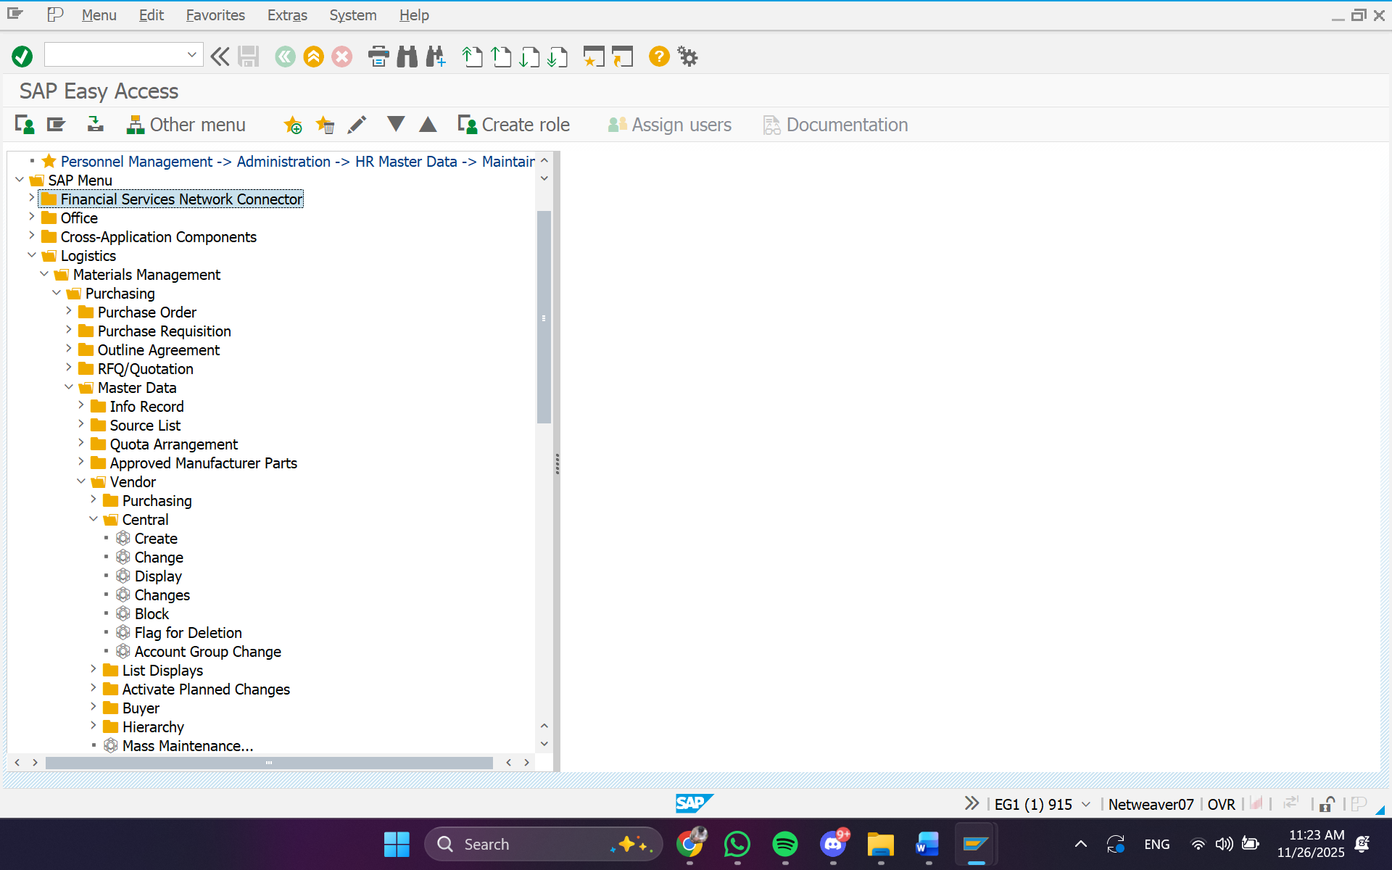

* 1. *Place your cursor in the Purch. organization field and then Press F1 key*
  2. *Choose Technical information*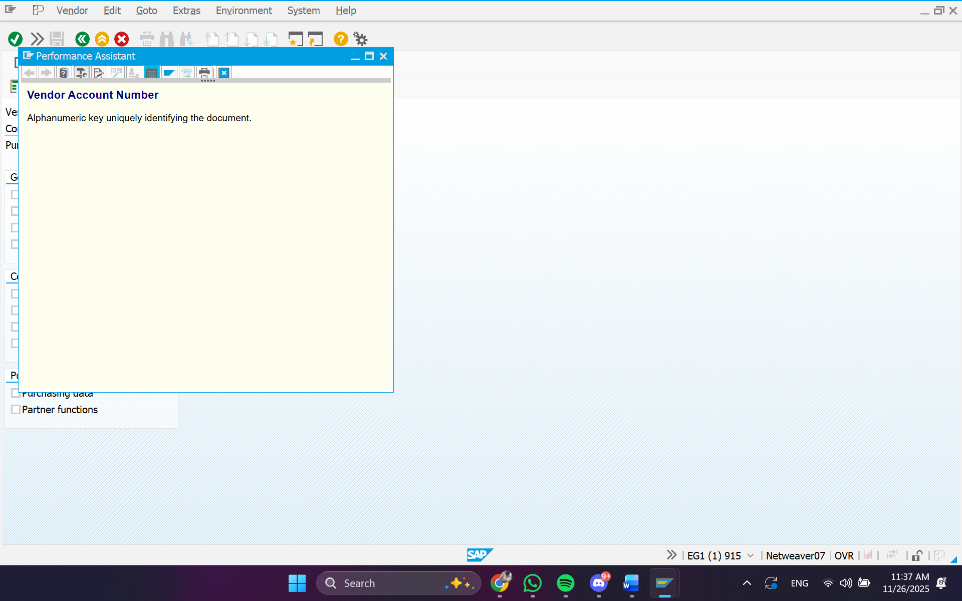
  3. *locate the parameter ID, which should be EKO*

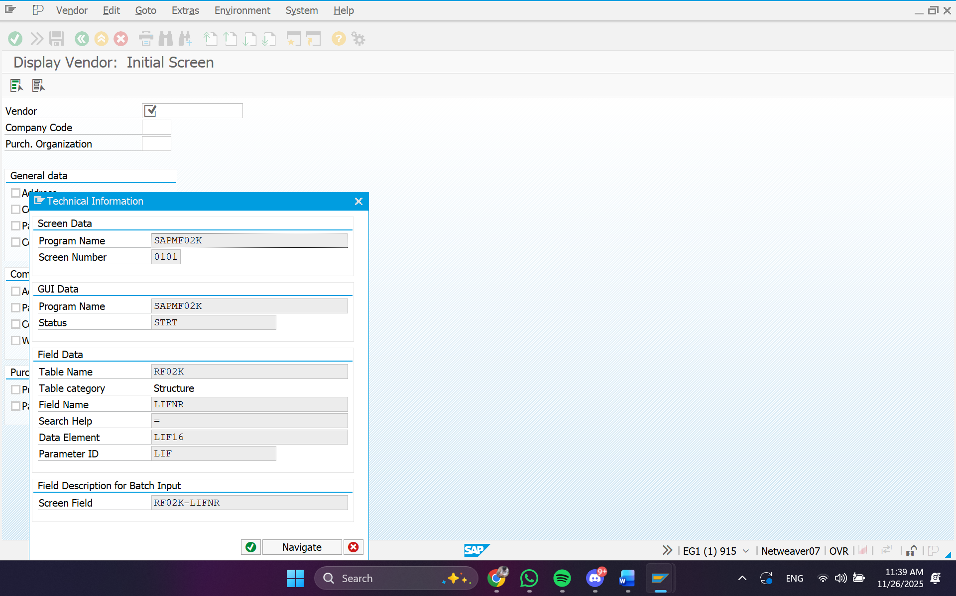

1. **Find the possible values for the purchasing organization.**
   1. *Place your cursor in Purch. Organization field and then press the F4 key.*
   2. *Choose Start Search.*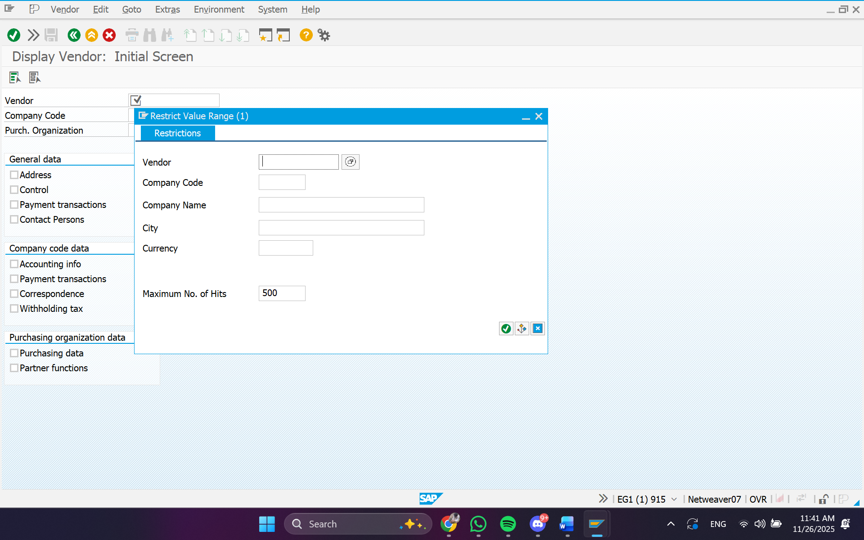
   3. *Confirm that purchasing organization 1000 is a valid entry for this field.*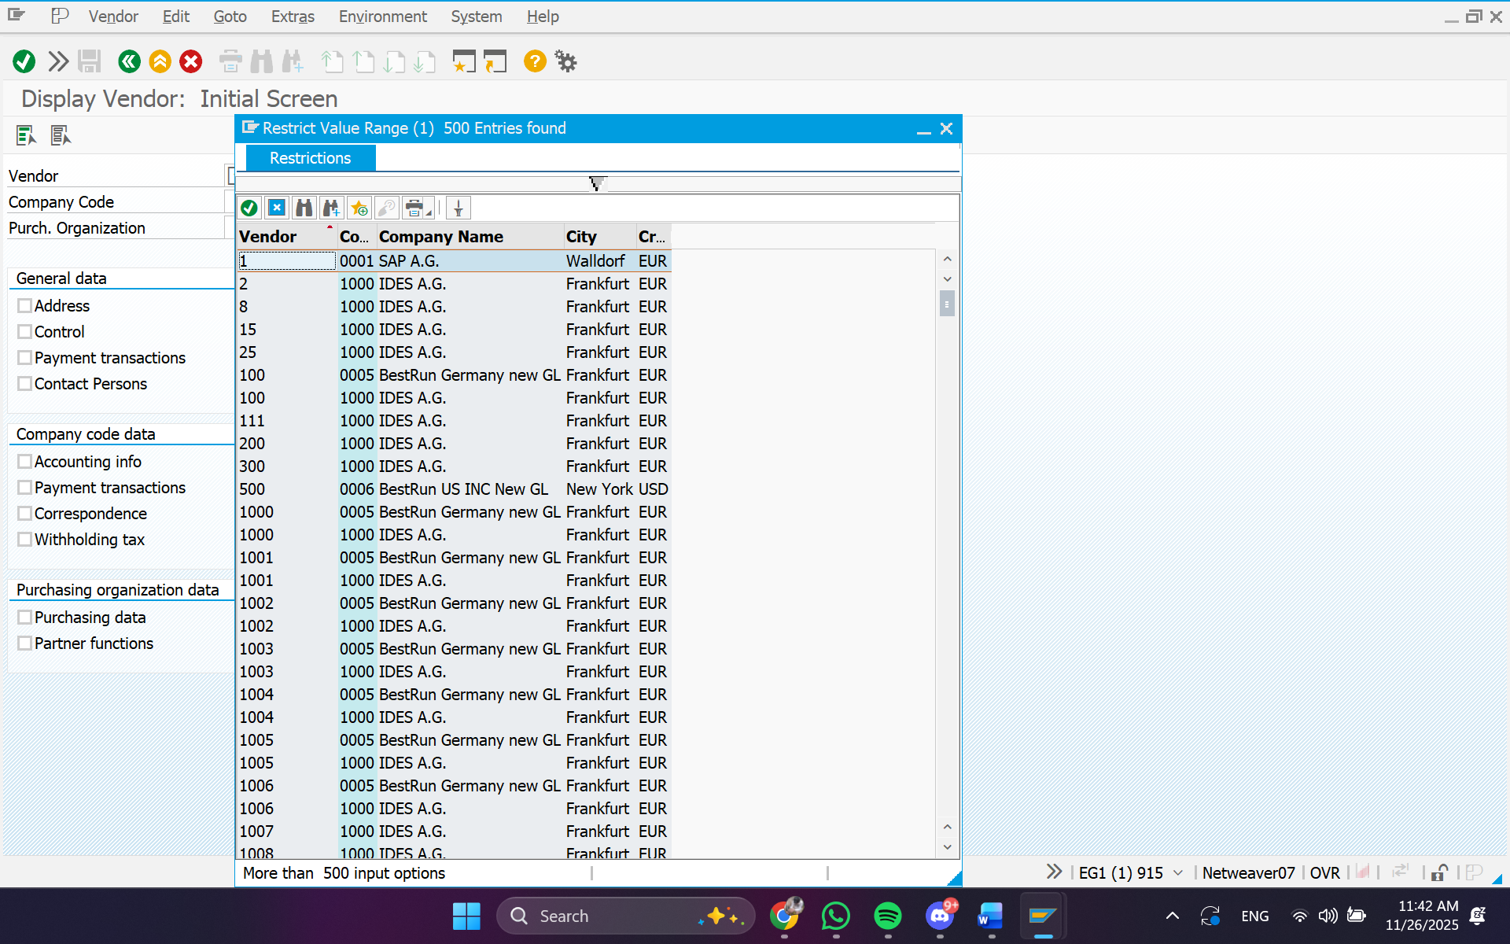
2. **Set your value for the purchasing organization in your user profile using the System menu**
   1. *From the Menu bar, choose System ⭢ User profile ⭢ Own data*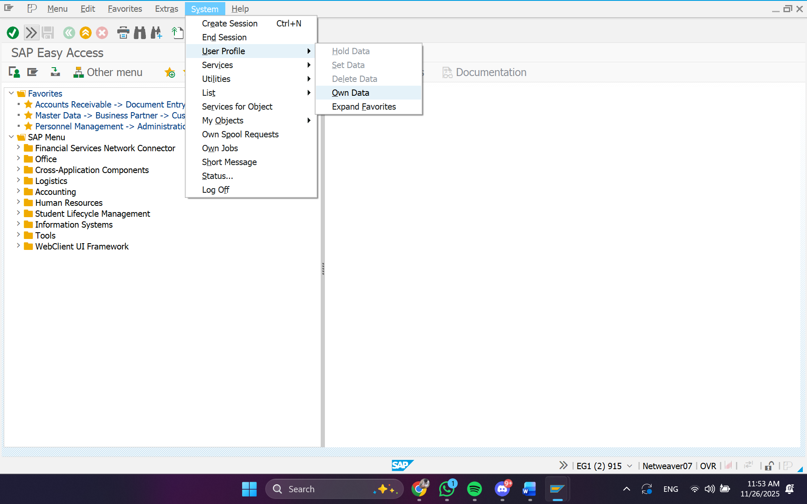
   2. *Choose the Parameters tab.*
   3. *Enter EKO in the Parameters field.*
   4. *Enter 1000 in the Parameter Values field.*
   5. *Press Enter.*
   6. *Then, Choose Save.*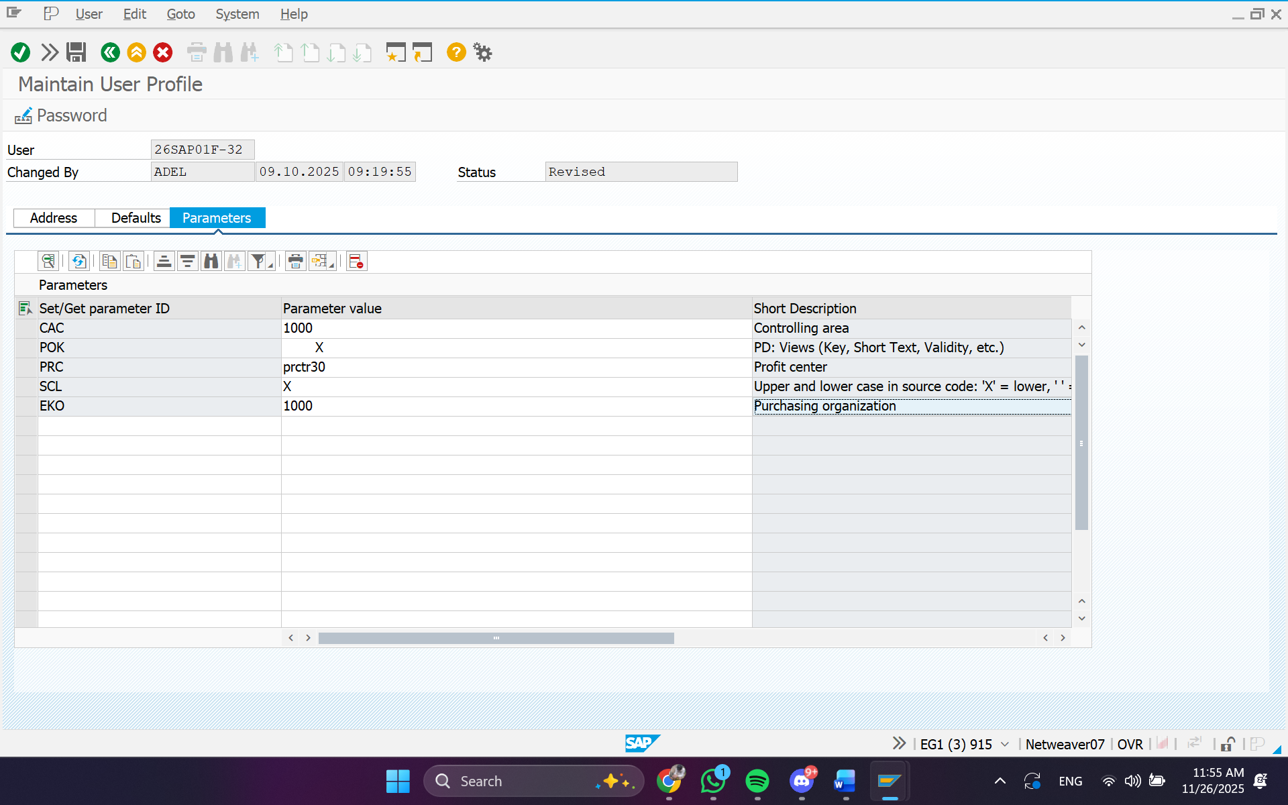
3. **Confirm that the value for the purchasing organization defaults to 1000.**
   1. *Enter transaction XK03 in the command field.*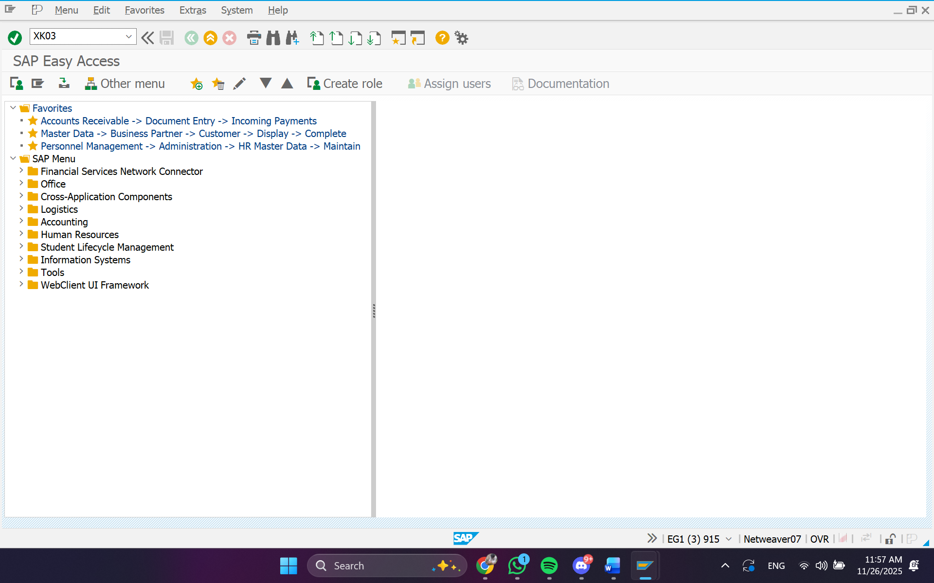
   2. *Confirm that 1000 is the default value in the Purch. organization field.*

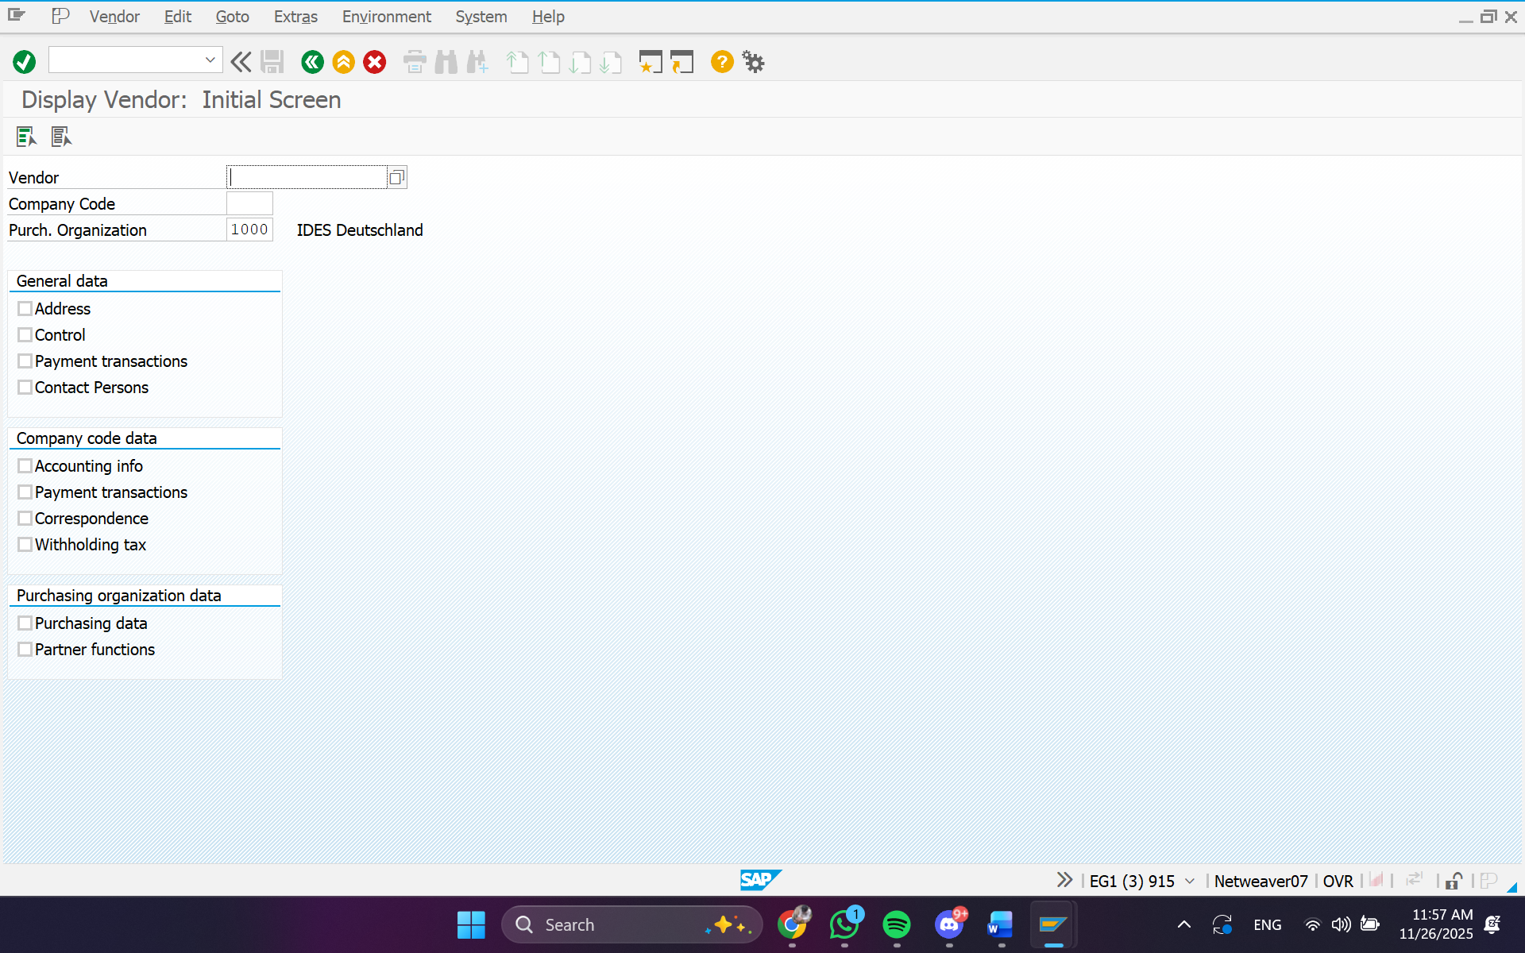

#### UNIT 3 - SYSTEM WIDE CONCEPTS

**Exercise 3-1: Display and Change a Customer Master**

Task:

1. **Display the customer master record**
   1. *From SAP Easy Access menu, choose Logistics ⭢ Sales and Distribution ⭢*

*Master Data ⭢ Business Partners ⭢ Customer ⭢ Display.*

*Double-click Complete.*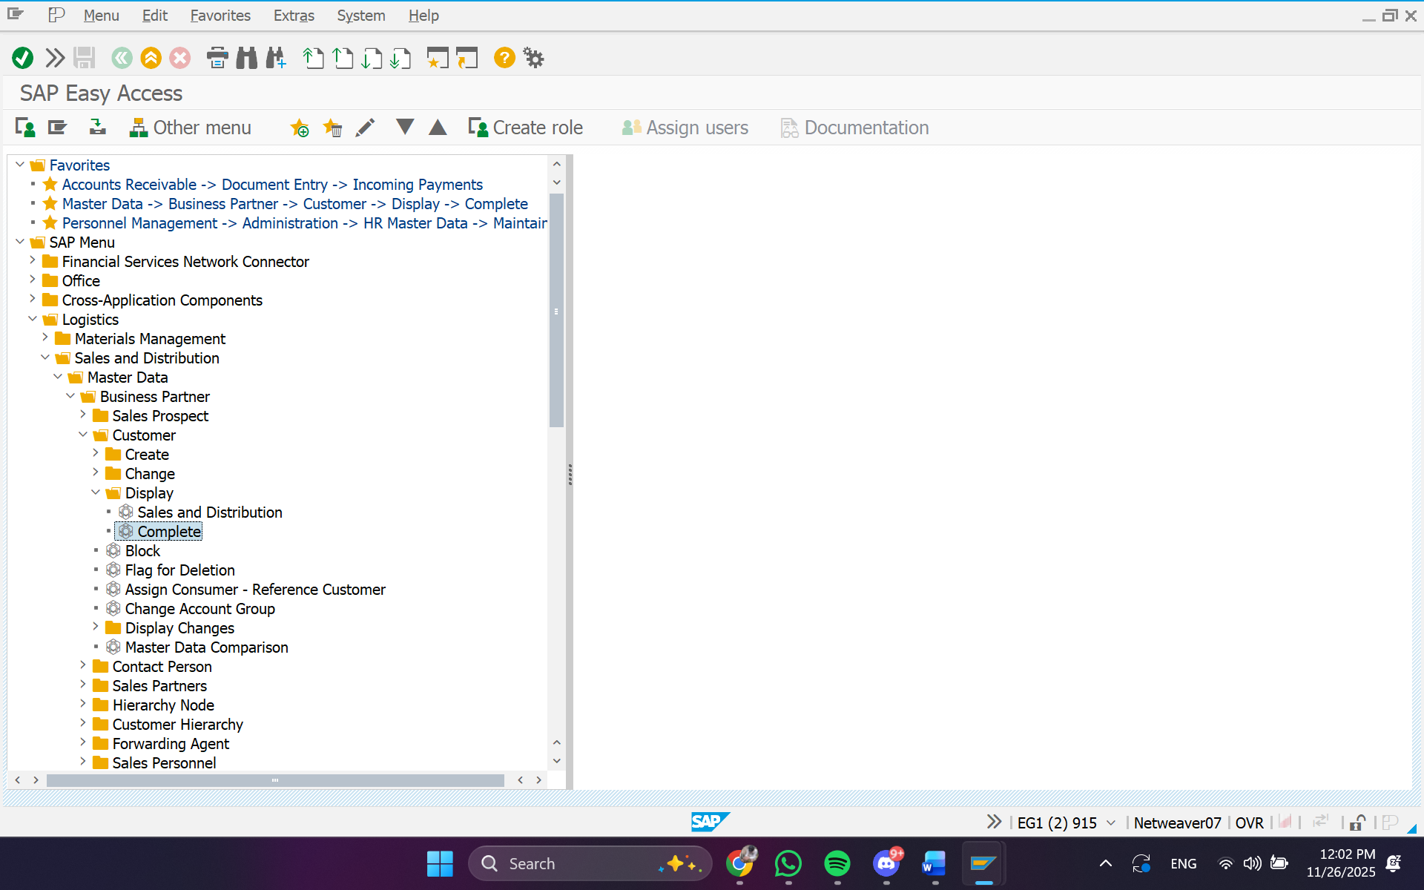

* 1. *Enter the information from the table above.*

*Choose Enter.*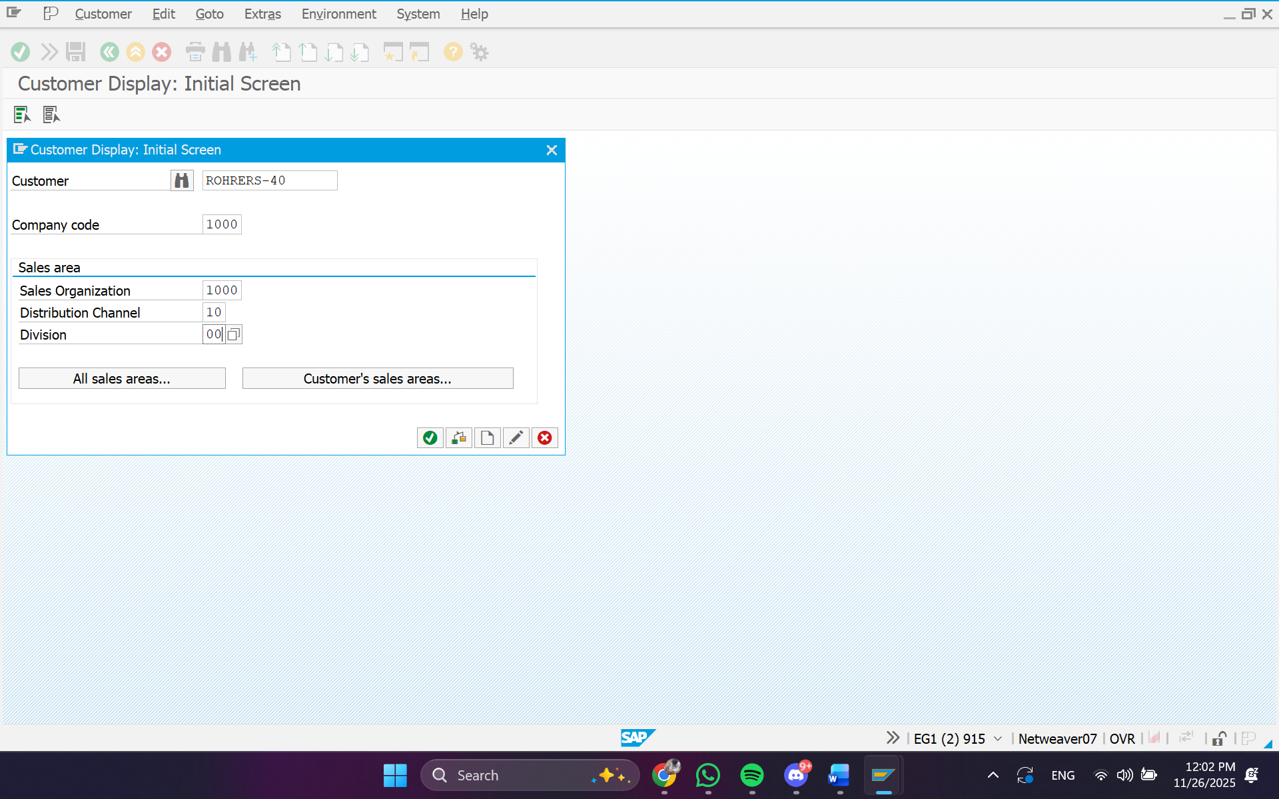

1. **Locate the following General Data**
   1. *Choose the General Data icon*
   2. *Choose the Address tab*

*Record the Street name in the table provided above: Waldstrasse 86-90*

*Record City in the table provided above: Berlin*

*Record the Search term in the table provided above: SAP01* 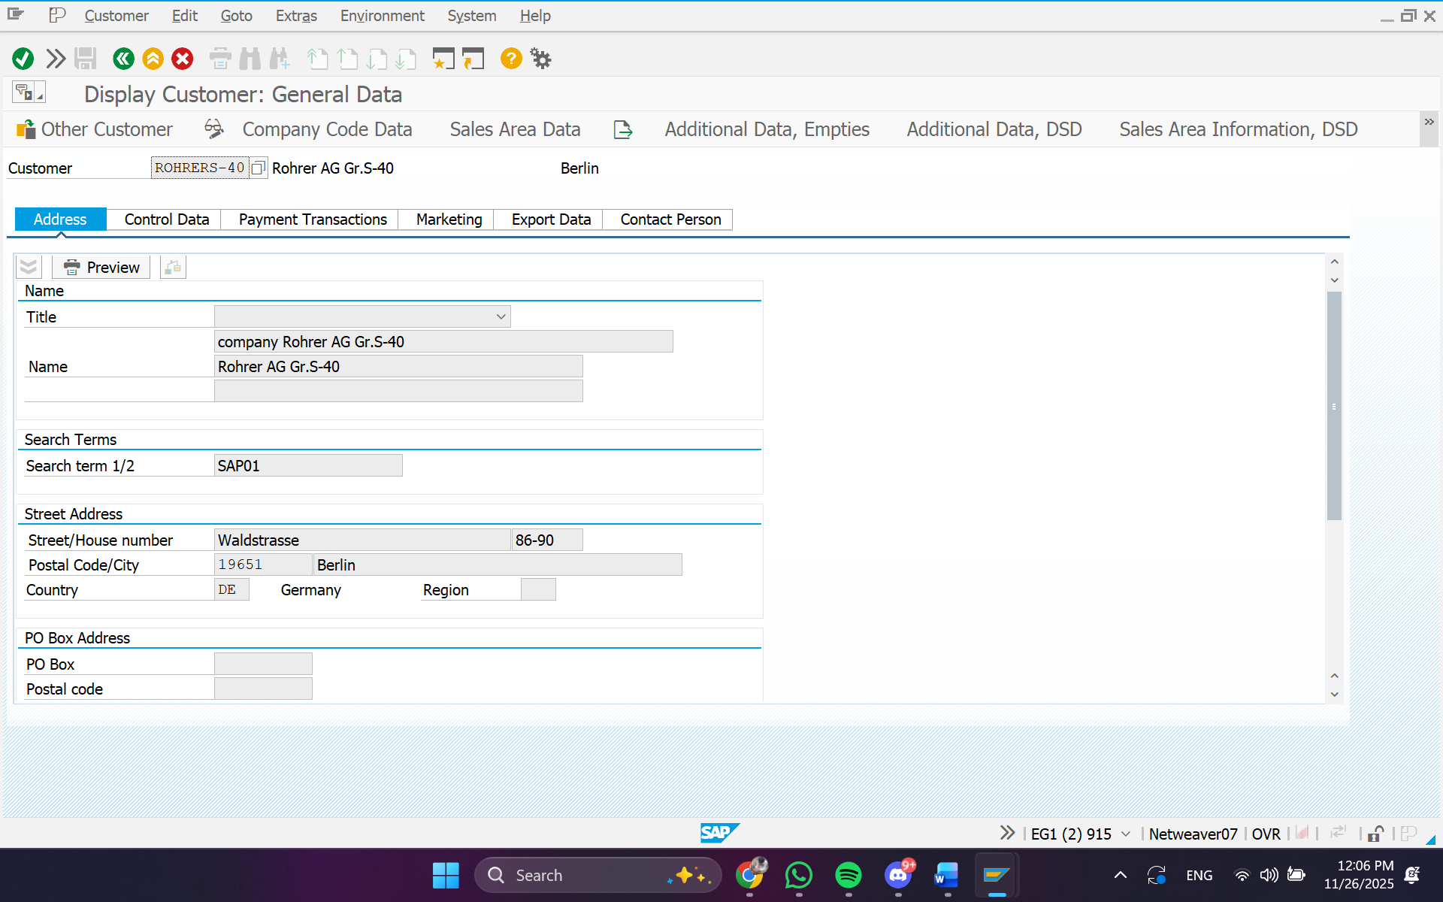

1. **Locate the following Company Code Data**

*a. Choose the Company Code Data icon*

*b. Choose the Account management tab...*

*c. Record the Recon. Account in the table provided above: 140000*

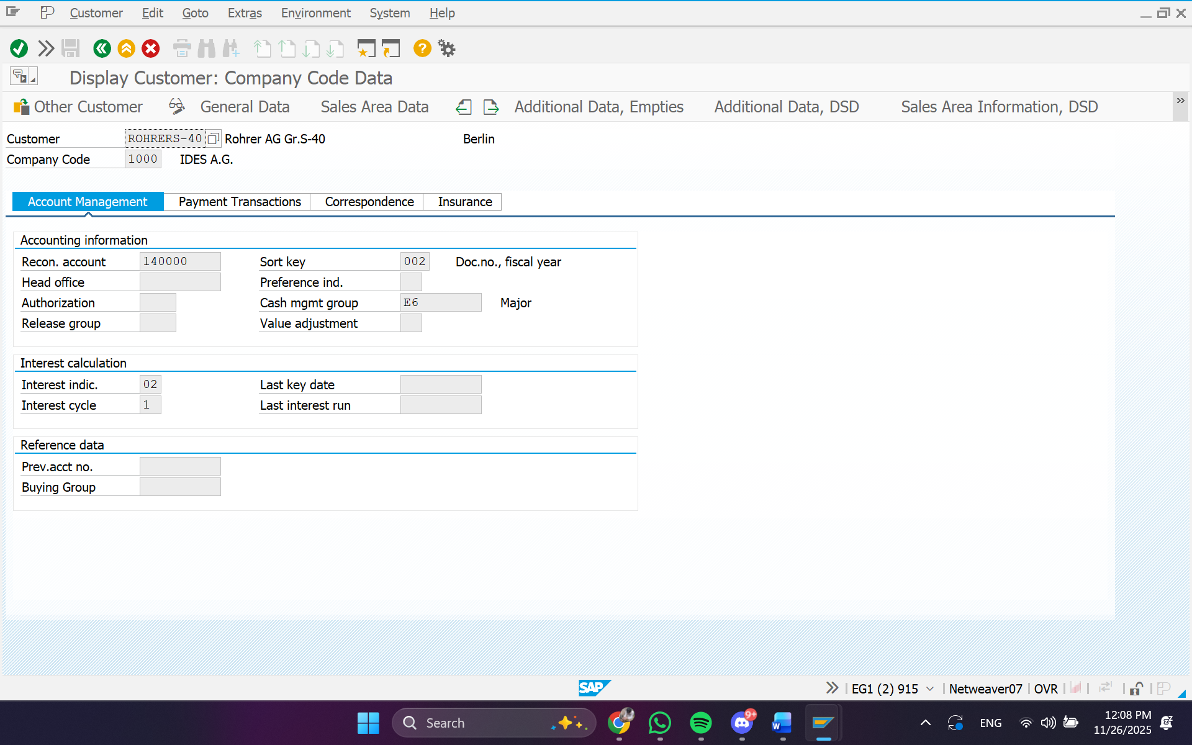

1. **Locate the following Sales Area Data**
   1. *Choose the Sales Area Data icon*

*b. Choose the Shipping tab*

*Record the Shipping conditions in the table provided above: 02 (standard)...*

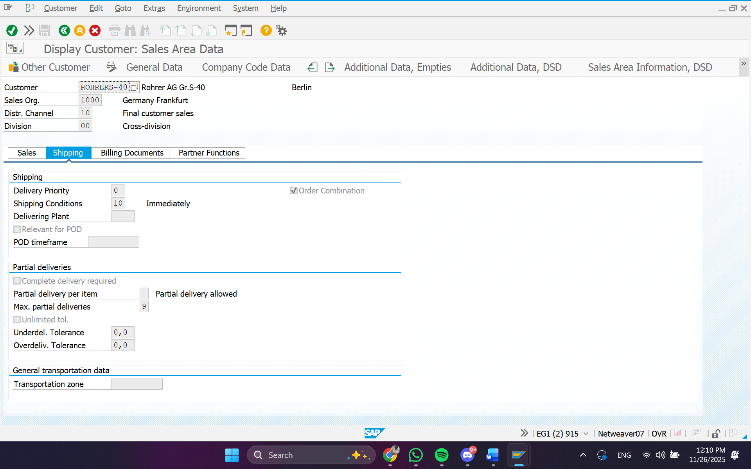

*.*

*C, Choose the Billing document tab  
d. Record the Terms of payment in the table provided above: ZB01*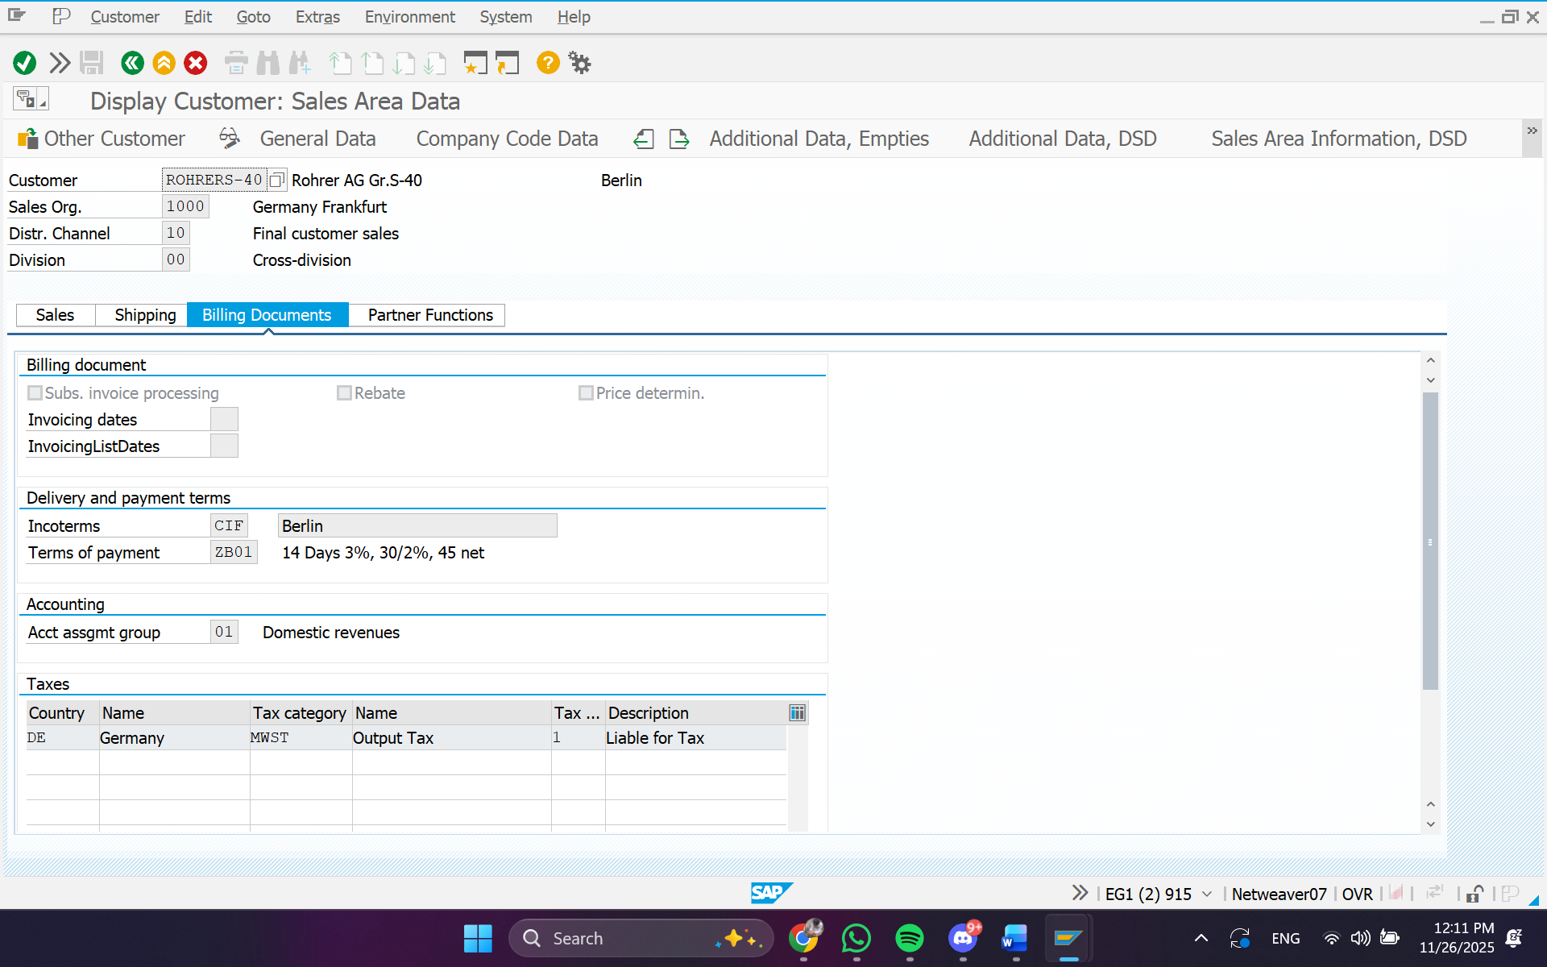

1. **Change the following information in the customer master record.**
   1. *From the SAP Easy Access menu, choose Logistics ⭢ Sales and Distribution ⭢*

*Master Data ⭢ Business Partners ⭢ Customer ⭢ Change*

*Double-click Complete*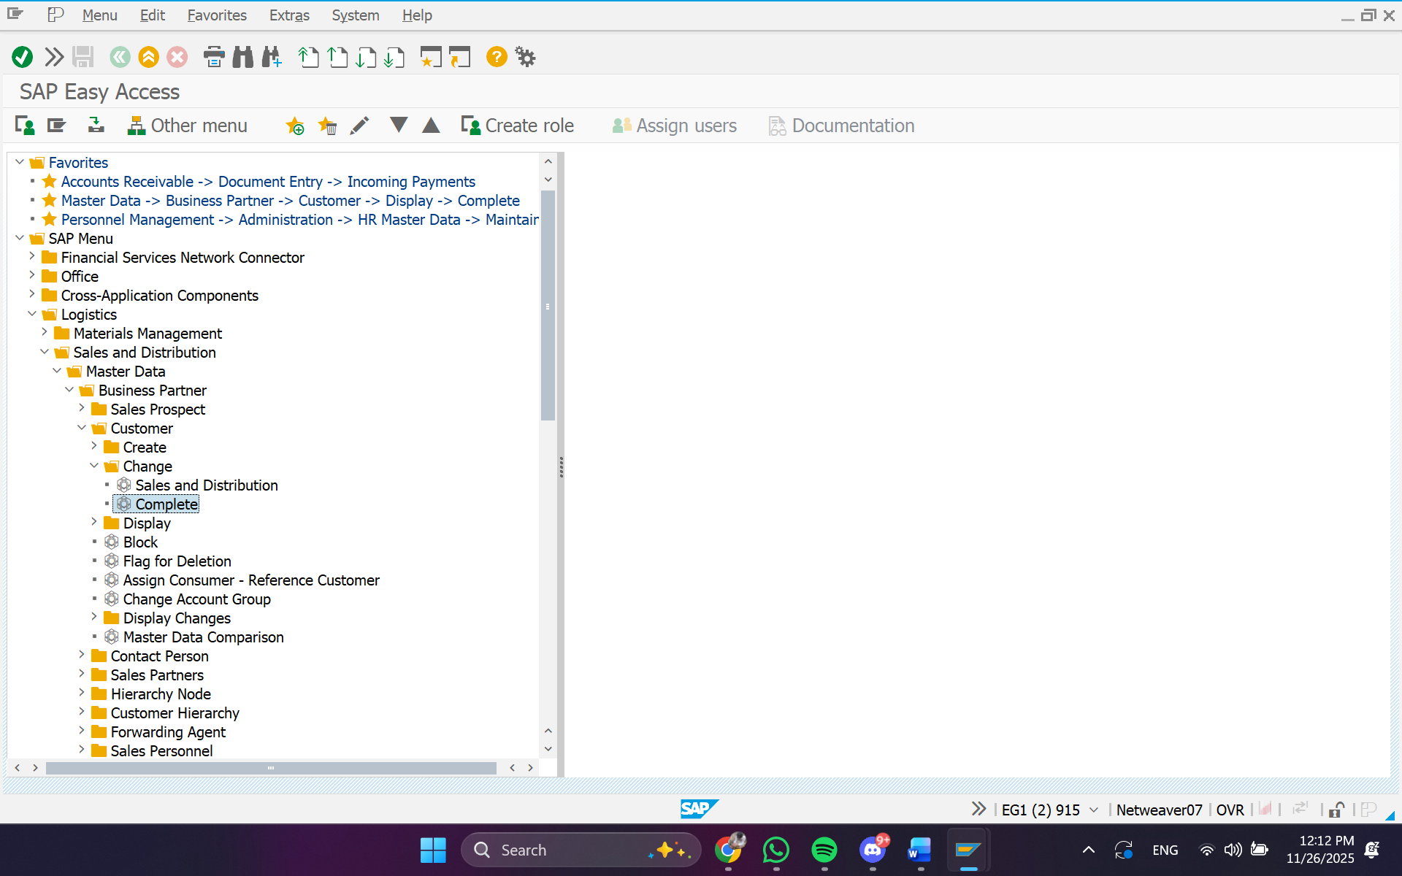

* 1. Enter the information below and then Choose Enter

Customer: Rohrer*-##

Company Code: 1000

Sales Organization: 1000

Distribution Channel: 10

Division: 00  
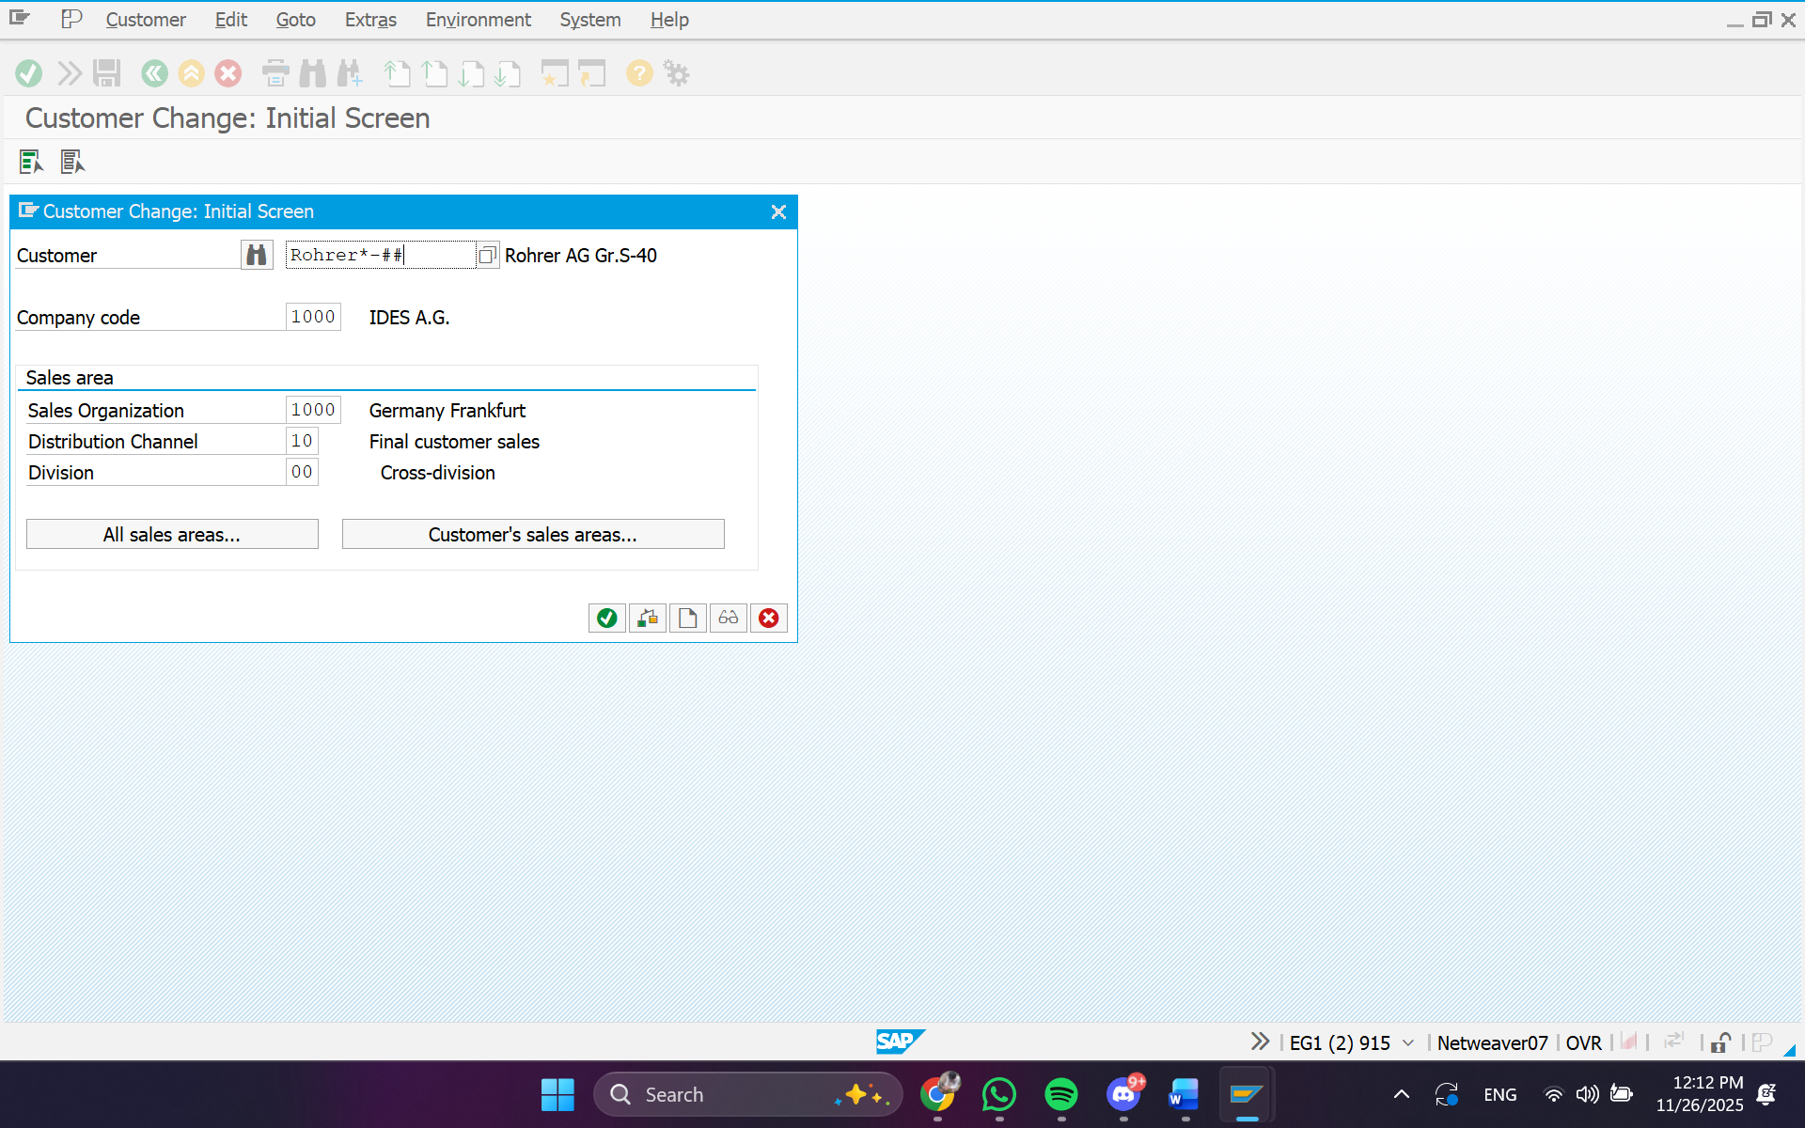

c. Change the Language field in General Data to English, and then click Sales Area Data.  
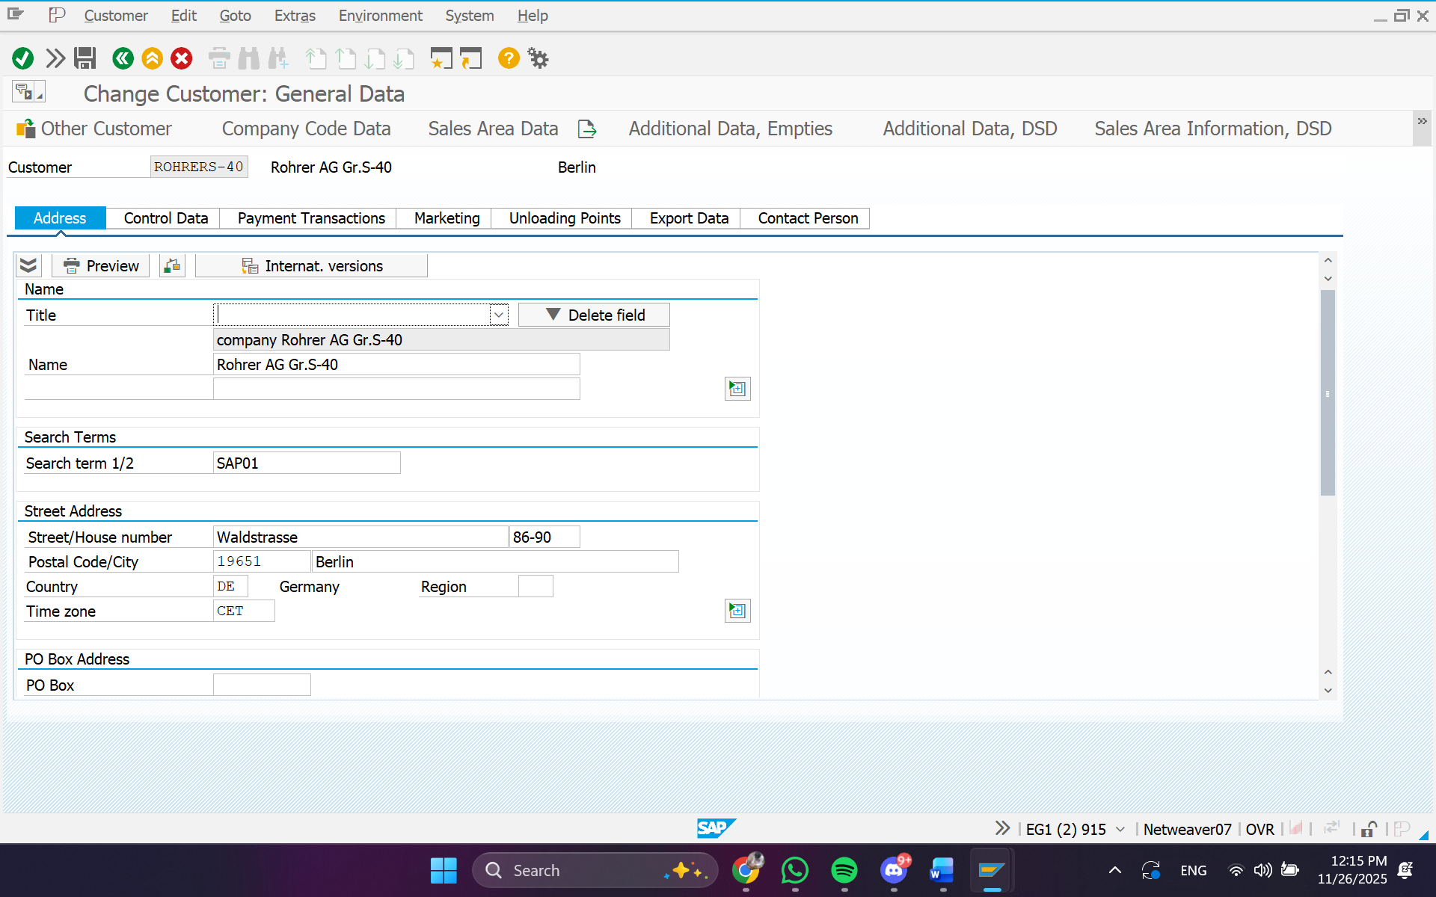

d. Change the Shipping Condition field in Sales Area Data/Shipping tab to 10 (immediately).

e. Choose Enter.

Then, Choose Save.  
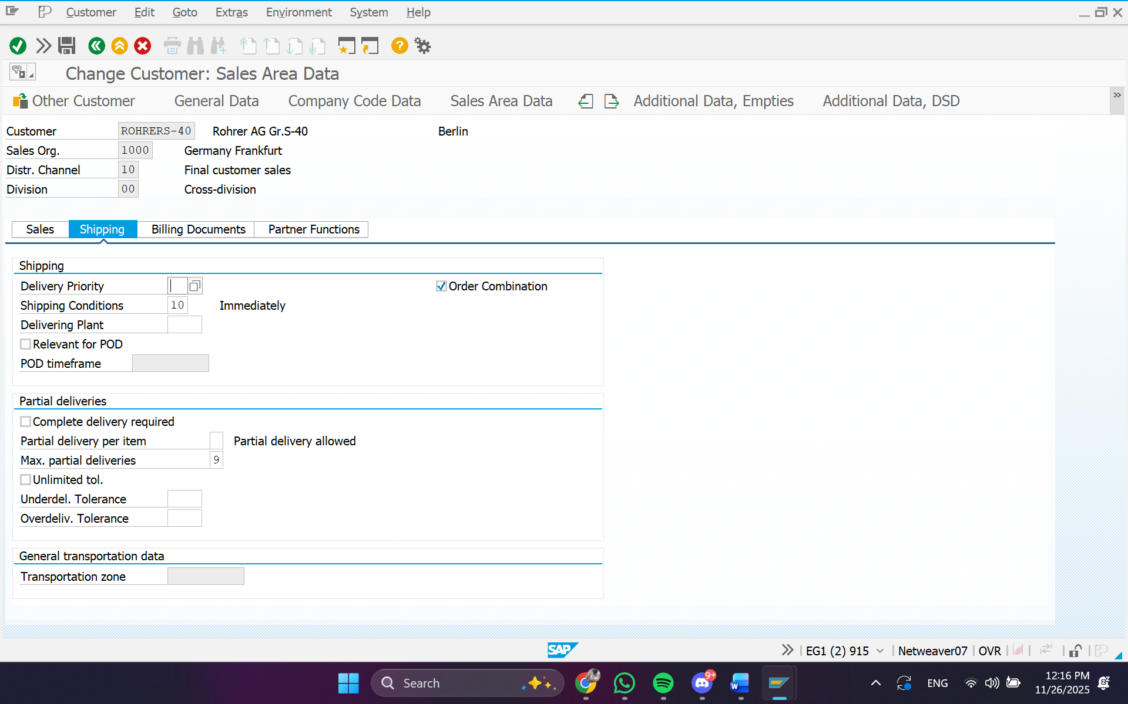  
You will receive a system message that the customer master record has been created.

#### Exercise 3-2: Display a Material Master

Task:

1. **Display the material master record**
   1. *[Screenshoot]*
   2. *...*
   3. *...*
   4. *...*
2. **Confirm the data by entering the information in the Data column of the table provided.**
   1. *[Screenshoot]*
   2. *...*
   3. *...*
   4. *...*

#### Exercise 3-3: Creating a New Material Master Record

Task:

1. **Create a material master record**
   1. *From the SAP Easy Access menu, choose Logistics ⭢ Materials Management*

*⭢ Material Master ⭢ Material ⭢ Display*

*Choose Display Current*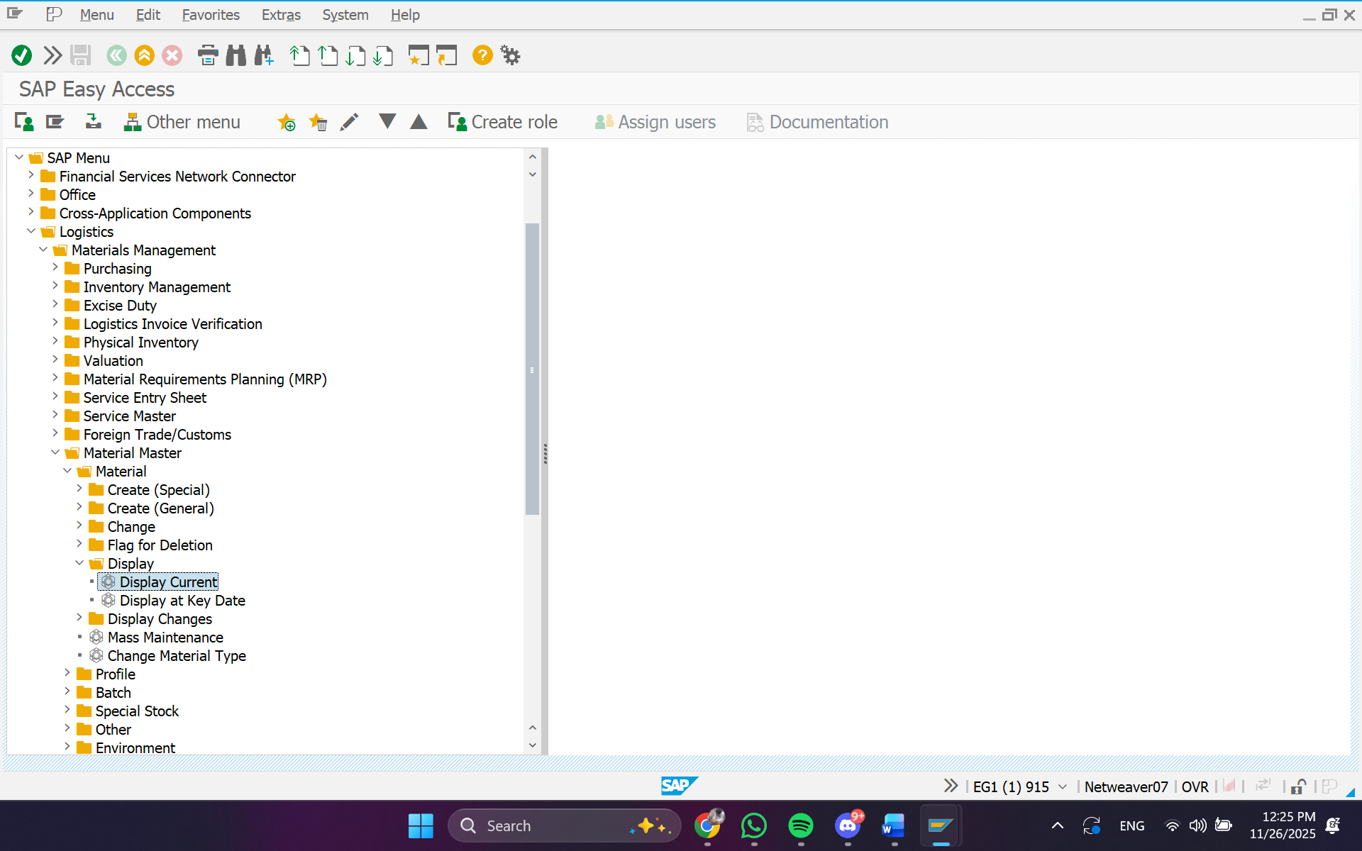

* 1. *Enter Material : 578, then click Select View(s)*

*Select the Basic Data 1 view*

*Select the Sales: Sales Org. Data 1 view*

*Select the Plant Stock view*

*Choose Continue/Enter*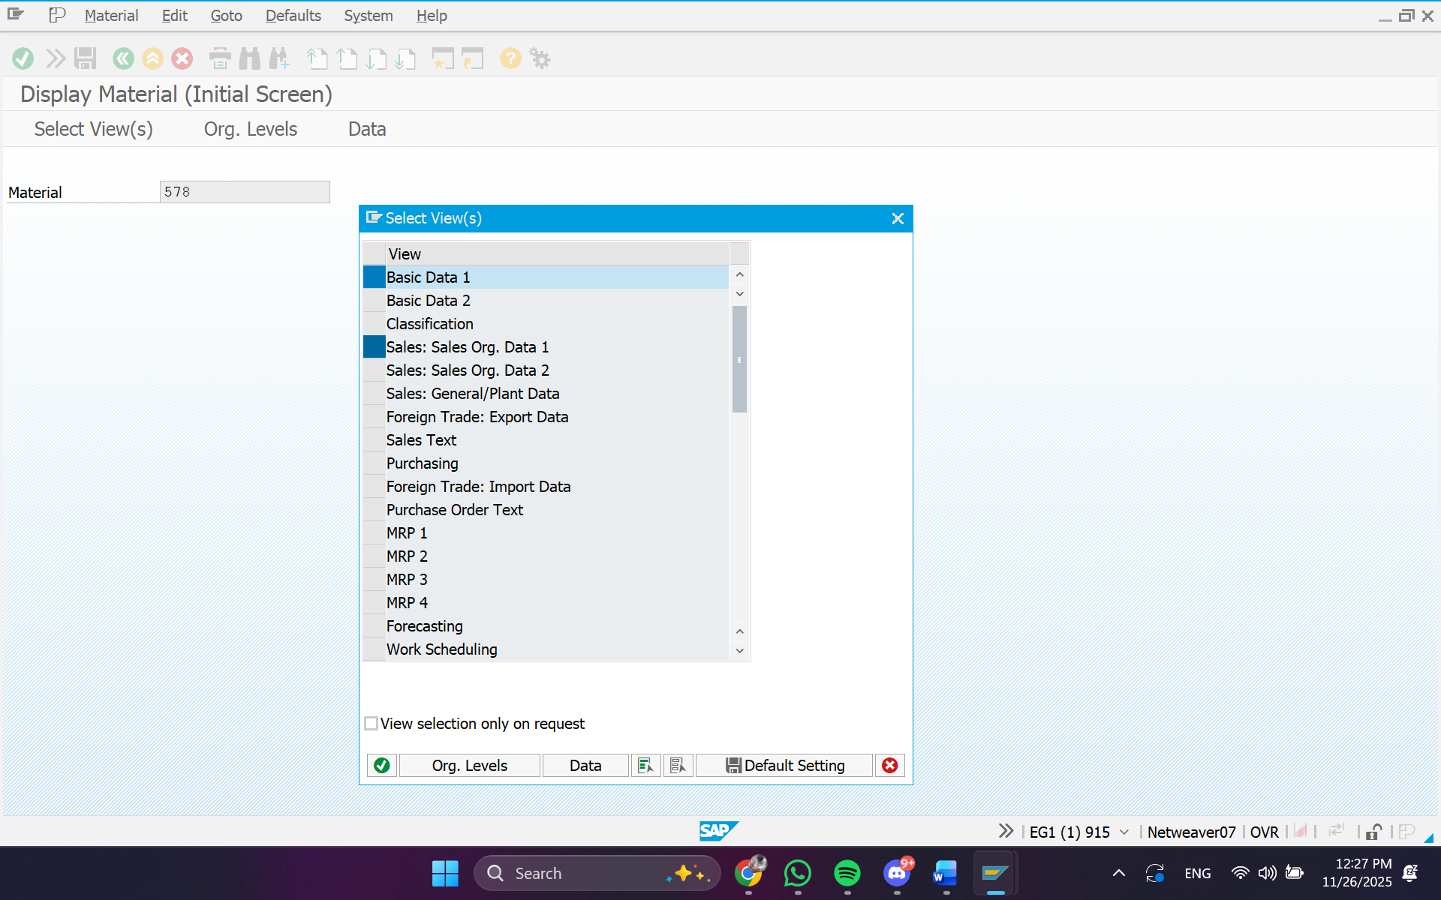

* 1. *Enter Plant: 1200*

*Enter Sales org.: 1000*

*Enter Distr. Channel: 10*

*Choose Continue/Enter*

1. 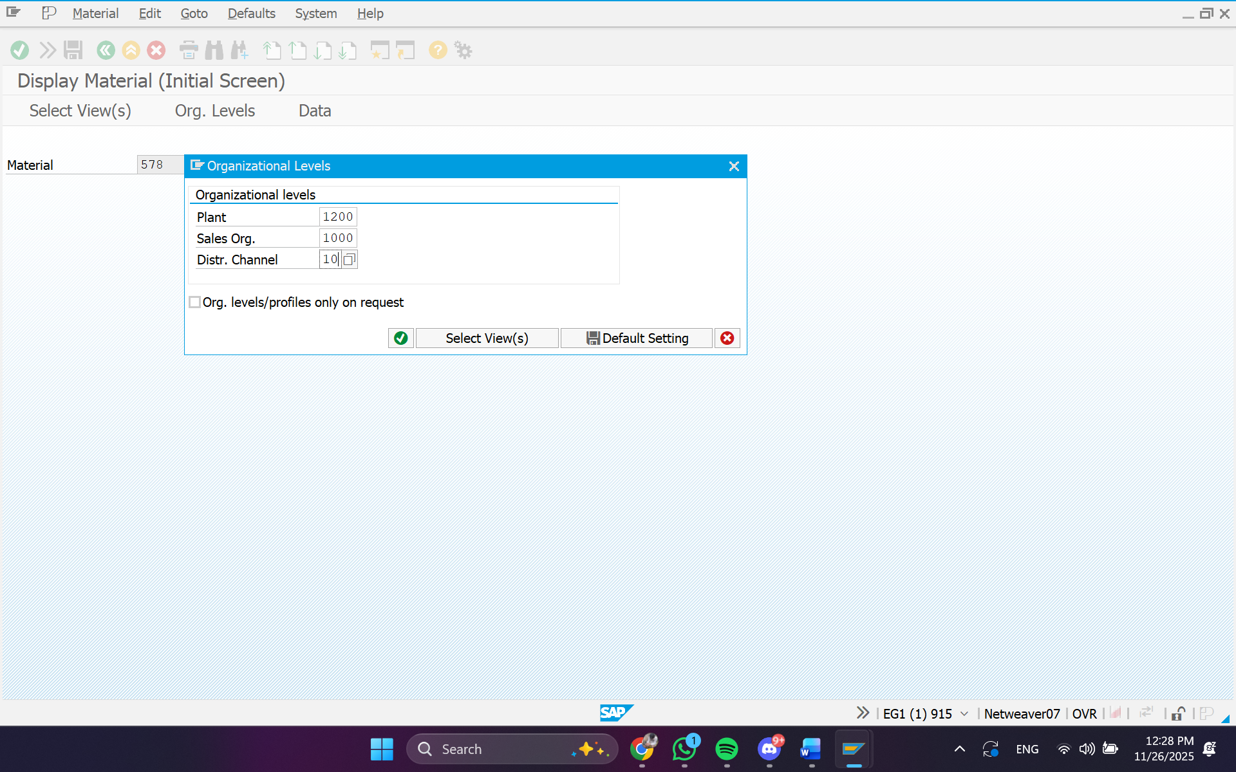 **Navigate through the three different views and enter the data**
   1. *[Screenshoot]*
   2. *...*
   3. *...*
   4. *...*
   5. *...*
   6. *...*
   7. *...*
   8. *...*
   9. *...*
   10. *...*



**TERIMAKASIH**

~~Selamat Mengerjakan~~